HOCHIMINH CITY UNIVERSITY OF TECHNOLOGY | SOCIALIST REPUBLIC OF VIETNAM
INSTITUTE OF INTERNATIONAL EDUCATION | Independence - Freedom – Happiness

Course: | CMP373 | Practice in Computer Networks
Group: | Q01
Lecturer's name: |  | THAI QUOC KHUONG

Student Name
Student ID

Please send me an email with two attached files:
- A Word document named: “StudentName_StudentID_Final Lab-23DTHQA1.docx”
- A Packet Tracer file named: “StudentName_StudentID_Final Lab-23DTHQA1.pkt”
Send it to tqkhuong261@gmail.com.
Your submission will only be considered valid if I receive it before 11:59 PM on Sunday, December 28, 2025.
Note: You must also receive a reply from me confirming receipt for the submission to be valid.

Give the Logical Topology
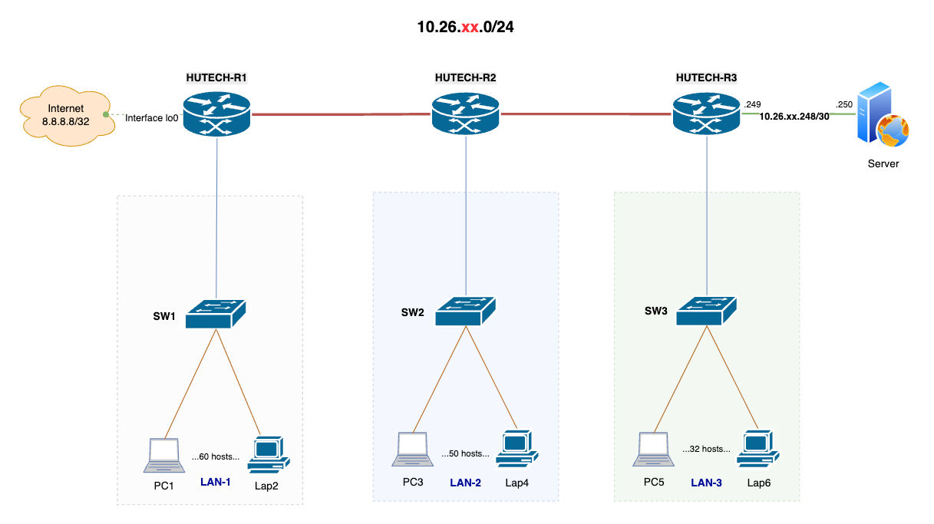

10.26.xx.0/24

Task 1: (2 points)
Subnet the 10.26.xx.0/24 network into appropriate subnets and assign them to suitable network segments, where “xx” represents your assigned student number as provided in the table below.
- The first usable host IP address in each subnet should be assigned to the router as the gateway for the respective LANs.
- Devices within each LAN segment should be assigned the second usable host IP address and the last usable host IP address within the subnet’s usable IP range.

No. Student ID Student name  01 2180606918 Đoàn Việt Anh  02 2380600036 Đinh Nguyễn Tú Anh  03 2380600156 Nguyễn Gia Bảo  04 2380600218 Huỳnh Ngọc Minh Châu  05 2380600258 Nguyễn Quốc Cường  06 2380600742 Sơn Nhật Hoàng  07 2380600748 Vũ Khánh Hoàng  08 2380600839 Ngô Quốc Huy  09 2380600979 Lê Nguyễn Bảo Khang  10 2380604319 Diệp Tùng Lâm  11 2380607658 Tô Hoàng Nhân  12 2380604964 Đặng Lê Thái Phong  13 2380601769 Nguyễn Đình Phước  14 2380601778 Trương Thiên Phước  15 2380601827 Lê Minh Quân  16 2380601854 Nguyễn Đình Quốc  17 2380601894 Lê Tâm Hoàng Sang  18 2380601935 Cao Thanh Tài  19 2380601947 Mai Thanh Tài  20 2380602072 Lâm Trịnh Anh Thắng  21 2380602052 Trần Duy Thành  22 2380602289 Huỳnh Phương Trâm  23 2380602443 Lầu Vũ Hoài Tuấn  24 2380602567 Pốc Nghiệp Vinh  25 2380602573 Võ Quang Vinh  26 2280601067 Trần Huy Hoàng  27 (example) Thái Quốc Khương | Example:  My name is Khuong, and my asssigned number (No.) is 27.  Therefor, I use the Network 10.26.27.0/24 for subneting.  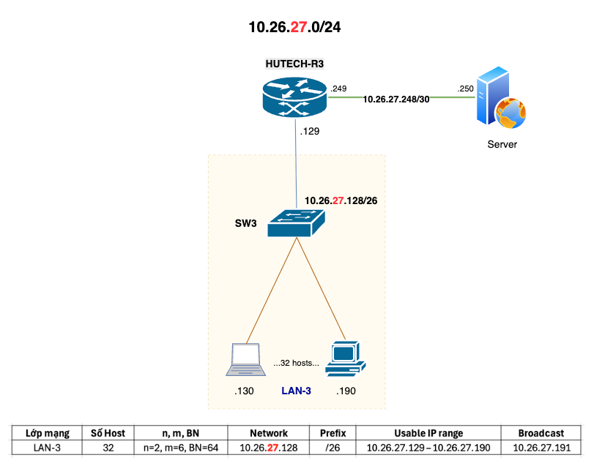

Fill in the information you have completed into the following table:
- N: Number of Network bits (N=24)
- H: Number of Host bits (H=8)
- n: Borrowed bits
- m: Remaining host bits (after borrowing)
- Step: Step size
Zone | Hosts | n/m/Step =? | Subnet | Prefix | First IP host | Last IP host
LAN-1 |  |  | 10.26.xx.?
LAN-2 |  |  | 10.26.xx.?
LAN-3 |  |  | 10.26.xx.?
R1-R2 |  |  | 10.26.xx.?
R2-R3 |  |  | 10.26.xx.?
R3-Ser |  |  | 10.26.xx.?

Task 2: (2 points)
- Implement the above topology using Packet Tracer software.
- Make the connections using the corresponding cable connections.
- Add network labels to the topology in Packet Tracer.
Capture a screenshot of the completed connections and network layers in the topology, then include it in the results section.

@ Result:
- The image below is only an example. Please delete it and capture a new screenshot from your own Packet Tracer lab that correctly matches the required topology.
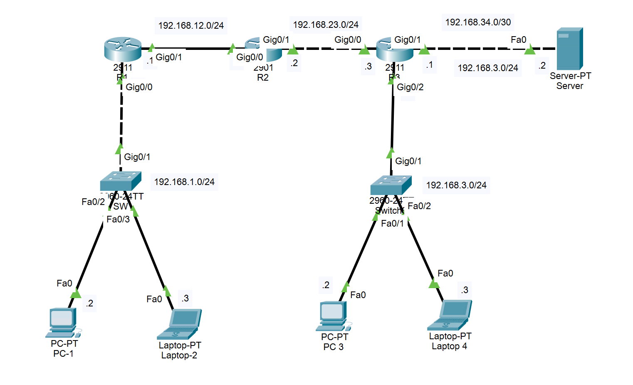

Task 3: (2 points)
Configure IP addresses for the host devices in LAN-1, LAN-2, LAN-3, LAN-4 and the Server as planned in Task 1.
Set the Hostname, Enable password to hutech, and Console password to cisco on all Routers.

Task 4: (2 points)
Configure static routing so that PCs in different LANs can fully ping each other and reach the Server.
@ Result:
- Ping from LAN-1:PC1 to LAN-2:PC3

- Ping from LAN-2:PC3 to LAN-3:PC5

- Ping from LAN-3:Lap6 to LAN-1:Lap2

- Ping from LAN-2:Lap4 to Server

- Ping from LAN-3:PC5 to Internet 8.8.8.8 (Interface loopback on HUTECH-R1)

Task 5: (2 points)
  - Capture a screenshot that fully displays the ports on the Packet Tracer topology. Show the CDP (Cisco Discovery Protocol) output on Router HUTECH-R2 using the CLI.
Fill in the results in the table below.
@ Result:
- Topo:
- Table
End Device 1 | Port on Device 1 | End Device 2 | Port on Device 2
HUTECH-R2 | … | ? | …
HUTECH-R2 | … | ? | …
HUTECH-R2 | … | ? | …

  - Configure and enable Telnet access, then verify the Telnet connection from LAN-1:PC1 to HUTECH-R3 by showing the command output.
@ Result:
- Output command:

